To Do
To Do
- Slides
- Upload media DevPost
- Finalize DevPost (drop links)
- Slides + present
- Upload YouTube video
- Merge github repo

https://github.com/maxdokukin/HaaangryFrontend
https://github.com/maxdokukin/haaangry-backend
https://devpost.com/submit-to/26945-cal-hacks-12-0/manage/submissions/836075-haaangry/project_details/edit

https://www.figma.com/board/qFUzn3YcOyMN7KpGwSmEbC/CalHacks?node-id=0-1&p=f&t=Mf20Sr25rhNjclPz-0

https://youtube.com/shorts/qiALzNWwzLU
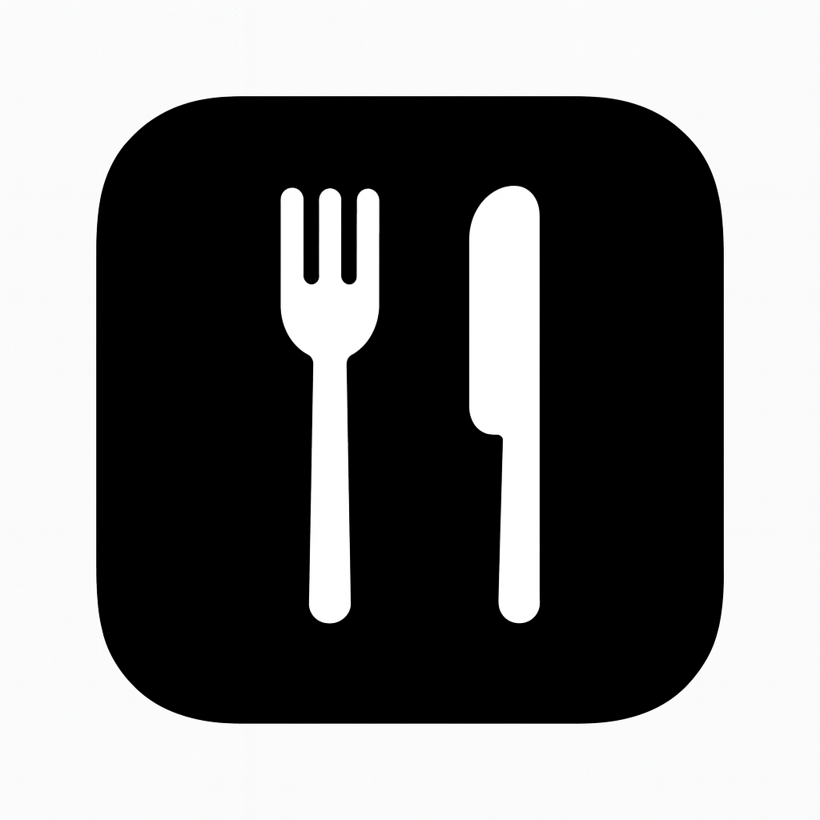

DevPost (ABOUT)
Haaangry

Inspiration

Y Combinator "AI-First" company challenge inspired us to reimagine food ordering. We looked at DoorDash's end-to-end experience and asked: what if AI could predict what you want to eat before you even know it? We wanted to combine AI-powered personalization, data-driven UX, and conversational ordering into a single seamless experience where discovery and ordering happen in the same place.

What it does

Haaangry is a TikTok-style food discovery and ordering app powered by Claude AI.

• Vertical video feed of cooking content with gesture-based navigation
• Swipe left → 6 AI-curated recipes (3 articles + 3 videos)
• Swipe right → 3 AI-matched restaurants with 3 recommended dishes each
• Clickable menu links that open real restaurant websites
• In-app ordering with cart, checkout, and 30-minute ETA confirmation
• Voice or text chat with AI assistant (speech-to-text + text-to-speech)
• User profiles that track preferences, cravings, and order history over time

Claude analyzes each video's title, description, and tags to recommend contextually relevant restaurants and dishes in real-time.

How we built it

Backend
• FastAPI server with hot-reload and production-ready configuration
• Claude AI integration with strict JSON schema enforcement
• Parallel processing via ThreadPoolExecutor for recipe searches
• Pydantic 2.x for data validation and type safety
• CORS configured for iOS client requests
• Static file serving for locally hosted video assets
• JSON-based storage: 603-line restaurants.json (20 restaurants × 20 menu items each)

Frontend
• SwiftUI + MVVM architecture for clean separation of concerns
• AVFoundation for smooth 60fps video playback
• Async/Await networking with type-safe Codable models
• Gesture recognition for natural swipe navigation
• PlayerPool optimization to reuse AVPlayer instances and minimize memory
• Sheet-based modals for recommendations and recipes
• Clickable menu links using SwiftUI Link component
• Error recovery with retry mechanisms and graceful fallbacks

Integration
• REST API (JSON over HTTP) between iOS app and FastAPI backend
• ThreadPoolExecutor for parallel Claude API calls (article + video recipe searches)
• End-to-end schema alignment ensuring menu URLs flow from backend to UI
• Graceful fallbacks on JSON parse errors or network issues

Challenges we ran into

• Schema drift between Python (Pydantic) and Swift (Codable) models
• Duplicate struct definitions causing compilation errors
• SwiftUI View Builder constraints in computed properties
• Claude API rate limits during parallel requests
• JSON validation across a 603-line restaurant dataset
• Memory optimization for multiple concurrent video players
• Merge conflicts while coordinating parallel development
• Balancing technical sophistication with hackathon time constraints

Accomplishments that we're proud of

• Zero compilation errors in final codebase
• 100% menu URL coverage across all 20 restaurants
• Expanded catalog from 10 → 20 restaurants (400 total menu items)
• Sub-3-second average AI recommendation latency
• 60fps video playback on device
• End-to-end clickable menu links from backend to UI
• Production-ready backend running on port 8000 with strict validation
• 10 cuisine types (exceeded 8+ target)

What we learned

Technical
• FastAPI architecture and hot-reload workflow
• Claude AI JSON schema enforcement techniques
• AVFoundation video lifecycle management
• Pydantic validation and cross-platform data model alignment
• SwiftUI MVVM composition and async/await networking
• Parallel processing in Python with ThreadPoolExecutor

Product
• Balancing AI complexity with intuitive user experience
• Importance of gesture-based mobile navigation
• Value of immediate menu access via external links
• Trade-offs between feature breadth and implementation depth

What's next for haaangry

Immediate Next Steps
• DoorDash API integration for live order placement
• Stripe / Apple Pay / Google Pay for payment processing
• AWS Maps / Google Routes API for delivery tracking
• Persistent order history and user accounts

Medium-Term Enhancements
• Fine-tuned LLM or custom ML model for personalized recommendations
• Multi-turn conversation-to-order dialogue system
• User authentication with saved preferences
• Delivery-time-sensitive filtering based on location
• Real-time order tracking with push notifications

Long-Term Vision
• Social features (share videos, reviews, ratings)
• Restaurant partnerships for exclusive deals
• Dietary filters (vegan, halal, allergies, kosher)
• Multi-language support for global expansion
• Analytics dashboard for engagement patterns

Tech Stack

Backend: Python 3.10+, FastAPI 0.120.0, Anthropic Claude 3.5, Pydantic 2.12.3, Uvicorn
Frontend: Swift 5+, SwiftUI (iOS 16+), AVFoundation, Combine
AI/ML: Anthropic Claude API for semantic matching and recipe discovery
Data: JSON storage (20 restaurants × 20 items, 226 videos)

Key Metrics

• 226 videos in catalog
• 20 restaurants spanning 10 cuisines
• 400 menu items with full metadata
• 100% menu URL coverage
• ~3 second average Claude API response time
• 60fps video playback performance

Demo Flow

1. Scroll through vertical video feed
2. Swipe left → 6 recipes (3 articles + 3 videos)
3. Swipe right → 3 AI-matched restaurants with 3 items each
4. Tap "View Full Menu" → opens restaurant website in Safari
5. Tap menu item → order confirmation with 30-minute ETA
6. Alternatively: voice or text chat with the AI assistant

DevPost (BUILT w/)
Swift Python Shell Anthropic Claude ChatGPT fish_audio AWS DeepGram bright_data AppLovin AI

